Franklin Harvey

CSCI-2270

Samantha Molner

Midterm Corrections

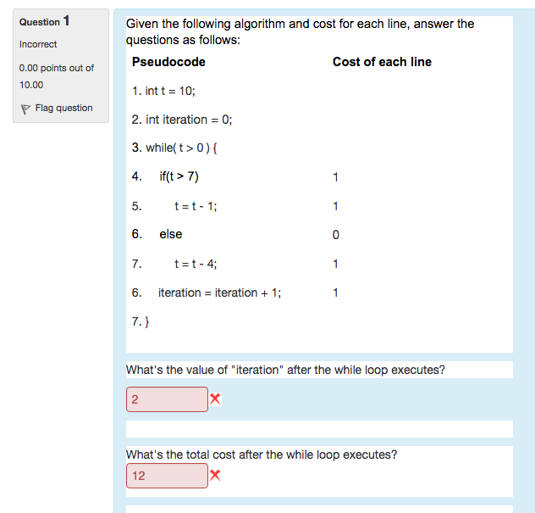

Essentially I originally mistook it to **not** add to iteration while t>7, which is incorrect.

The correct answer should be **5** & **15**.

Iterations should be 5, because the loop operates 5 times as follows:

Loop 1: t goes from 10 to 9, and iteration becomes 1 *(cost is 3)*

Loop 2: t goes from 9 to 8, and iteration becomes 2 *(cost is 3)*

Loop 3: t goes from 8 to 7, and iteration becomes 3 *(cost is 3)*

Loop 4: t fails the “if” condition and goes from 7 to 3. Iteration becomes 4. *(cost is 3)*

Loop 5: t fails again and becomes -1; iteration becomes 5. *(cost is 3)*

Then the while condition fails. Final cost is 15.